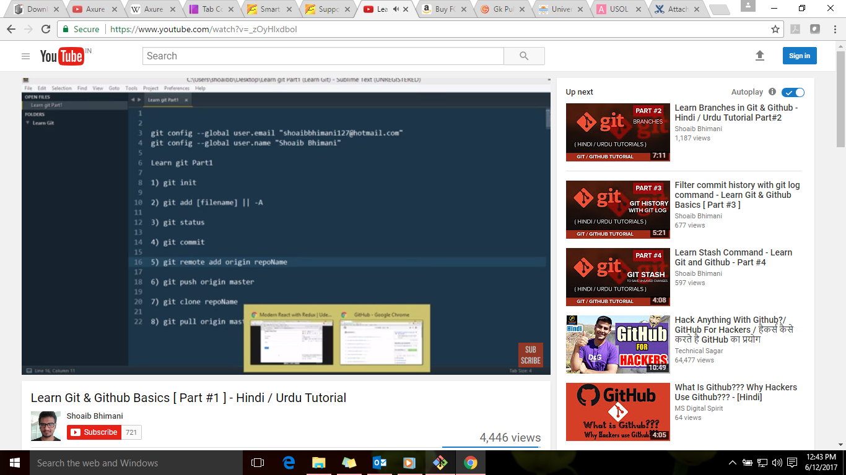

**Following are the commands to add the files from untrack to track**

Git add .

Git add –A

**Command to initialize the git :**

Git init

**Command to commit the file changes:**

Git commit –m “message”

**Command to know the status of files:**

Git status

Git remote add origin “link”

Git branch

Git push origin master

To clone the repository

Git clone “link”

Git pull origin master

**When two devs are working on same repository and wanted to commit there changes to that repository**

**By default repository is master**

Git branch --- will tell the branches

Git branch new_feature—will add new branch

Git checkout new_feature – to switch to new branch

Example:

**Now do the changes to the files and update the code in new branch, after the changes are done type command:**

Git add –A – it will add the files which were modified

Git commit –m “added feature.txt” – will commit the changes

Now type ls in new branch—it will give all the files

**Now next step is to merge all the branches**

**First go to master branch**

Git checkout master

And type ls—it will not show the newly added file which was added in new branch

Git merge master new_feature

Ls – type this command to see all the files

**Now we don’t need that branch type command:**

Git branch –d new_feature --- it will delete the branch

**Commands for Git Log:**

Git log

Git log –oneline --- it will give all the cached file names

Git log -2 --- it will provide the last 2 changes done in repository

Git log –p --- it will provide the list of all the files which were changed and changes were done

Git log --grep=“text” --- it will not search the pattern as pattern is case sensitive, so to add this situation type command:

Git log -i --grep=”text”

**Suppose user has done some changes to file and doesn’t commit the changes, before commit user wants to work on another change, so he will save the changes in local repository first and to do that type following commands:**

Git stash save “file name” – it will save the file in local repository

Git stash list --- it will provide the stash file

Once other work is completed, we need to commit the left changes that we left earlier and did not committed at that time, type following command:

Git stash apply “stash unique id”

Now to delete the local file type following command:

Git stash drop “stash unique id”

Git stash clear – if we need to delete more than one stash then type this command.